Traffic Flow Prediction Using Machine Learning

Kinshuk Kalinga Institute of Industrial Technology [22051081@kiit.ac.in](mailto:22051081@kiit.ac.in)

Aishwarya Verma Kalinga Institute of Industrial Technology [22051051@kiit.ac.in](mailto:22051051@kiit.ac.in)

Aakash Kumar Kalinga Institute of Industrial Technology [22051043@kiit.ac.in](mailto:22051043@kiit.ac.in)

Krishna Tanaya Panda Kalinga Institute of Industrial Technology [22053519@kiit.ac.in](mailto:22053519@kiit.ac.in)

Aniket Maity Kalinga Institute of Industrial Technology [22053660@kiit.ac.in](mailto:22053660@kiit.ac.in)

Bipasha Ray Kalinga Institute of Industrial Technology [22053939@kiit.ac.in](mailto:22053939@kiit.ac.in)

**Abstract— Traffic flow forecasting is vital for intelligent transportation systems to provide improved traffic control, congestion reduction, and city mobility planning. In this paper,a machine learning workflow consisting of data preparation, feature selection, and various classification methods is put forward to improve the accuracy of traffic flow forecasting. Min-Max to enhance the model's effectiveness and achieve uniformity, the dataset undergoes scaling, standardisation, and normalisation. To identify the most effective features impacting traffic flow, feature selection is carried out using Random Forest and Decision Tree classifiers. Various categorisation models, including Artificial Neural Networks (ANN), Recurrent Neural Networks (RNN), Random Forest, Support Vector Machines (SVM), Convolutional Neural Networks (CNN), Random Forest, and Long Short-Term Memory (LSTM), and Multi-SVM are trained and contrasted according to geometric mean, F1-score, recall, accuracy, and precision.**

**Apart from traffic flow forecasting, the research classifies traffic conditions into various degrees of congestion and determines peak and idle traffic hours by statistical methods. The research shows that Random Forest is very stable and accurate in traffic pattern classification and a great candidate for engineering use. The research outcomes provide traffic authorities with pragmatic suggestions towards maximizing traffic, enhancing infrastructural planning on the roads, and maximizing the productivity of commuters. The proposed plan can similarly be extended to real-time observation of traffic as well as adaptive control of traffic towards smart mobility options in the cities.**

***Keywords: Traffic flow forecasting, intelligent transportation systems, machine learning, feature selection, Decision Tree, Random Forest, CNN, ANN, traffic congestion classification, smart mobility.***

1. Introduction

It is required to establish efficient traffic flow forecasting and categorization models as urban traffic congestion is increasingly becoming a prevalent concern, which generates increased travel time, fuel consumption, pollution, and losses to the economy.

This project aims to improve traffic control and city planning by analysing traffic patterns using cutting-edge machine learning and deep learning techniques to categorise traffic conditions using historical data.5-minute traffic volume records are part of the data set, including derived day-of-week and hour-of-day dependent features along with important features such as vehicle count of flow and timestamps. Categorical attributes—such as traffic classes—are represented using numerical representations by utilizing label encoding strategies in order to transform them into machine learning model-acceptable representations.

To identify the most crucial features that contribute to traffic flow changes, Random Forest and Decision Tree classifiers are used for feature selection. Models in machine learning, including Decision Trees, Random Forests, Support Vector Machines (SVM), and Multi-SVM classifiers, have been employed to classify each time period as "Busy," "Average Busy," or "Not Busy" based on predetermined traffic levels. In order to increase prediction accuracy, sophisticated models like convolutional neural networks (CNNs), artificial neural networks (ANNs), recurrent neural networks (RNNs), and long short-term memory (LSTM) networks are employed to understand the intricate patterns and time-dependent relationships found in traffic data.

Considering the use of machine learning and deep learning algorithms, this illustration illustrates an organized workflow for predicting the movement of traffic. The Traffic Flow Dataset that is used at the start includes time stamps, flow of vehicles counts, and time-sensitive attributes (day, hour). By applying organize The encoding of to encode category characteristics and Decision Tree & Random Forest to pick key characteristics, that information is subjected to Feature Construction. The processed data is then input into algorithmic classification techniques including Random Forest, Decision Tree, SVM/Multi-SVM, and Deep Learning models (CNN, RNN, LSTM, ANN) in order to categorise the data into categories such as "Busy," "Average Busy," or "Not Busy." To assess how successfully the method predicts results, metrics such as accuracy, precision, recall, F1-score, and geometric mean are used. The final result is Traffic Research, which may be used to improve traffic utilization, intersection schedule, and civic scheduling methods through understanding busy and vacant hours as well as bottleneck statistics.

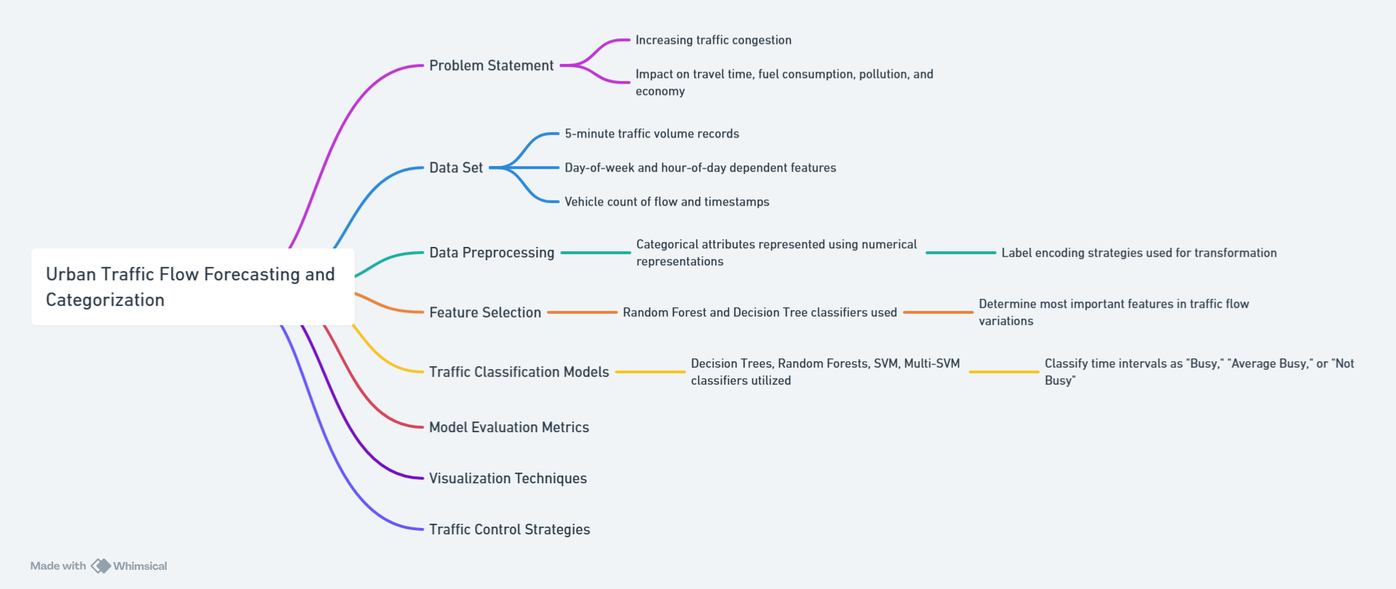

*Fig 1. presents a machine learning framework for forecasting and categorizing urban traffic flow using time-based data, preprocessing, feature selection, classification models, and evaluation strategies.*

Fully connected layers are employed for classification in the CNN model after using a 1D convolutional layer to gain spatial relations. The ANN model, in order to effectively process numerical data, consists of some thick layers along with the usage of activation functions. To precisely predict traffic classes, RNN and LSTM models process time-series data, and they are employed for handling sequential data.

Accuracy, precision, recall, geometric mean, and F1-score are some metrics for performance which are used to test models which provide end-to-end analysis of the performance of classification. In addition to depicting the advantages and limitations of every technique, comparison is indicative of the way in which deep models function in order to identify long-term patterns within traffic behavior. Visualizations for expressing classifier performance, including confusion matrices, line graphs, and bar charts, are created. These represent busiest and least busiest traffic periods on the basis of hourly average rates of flow. On the basis of hourly average flow rates, the project determines the busiest and less busy hours as well by using hourly average traffic flow rates. Each hour is categorized based on quartile thresholds.

Traffic control strategies are tuned taking into account and noting the busiest hour, highest traffic flow, and most idle hour with no vehicle movement. Based on machine learning and deep learning approaches, the project provides data-driven traffic control of urban traffic to facilitate ease of traffic signal control timing decisions, maximize road utilization, and commuter satisfaction. With more than one method of classification, a robust foundation is provided for traffic analysis to benefit transportation agencies, lawmakers, and urban planners to develop responsive and adaptive traffic control systems.

Furthermore, traffic flows are rendered less complicated through time-dependent characteristics, and traffic authorities can anticipate patterns of congestion in order to create and respond. Defining traffic flow conditions consistently is critical in congestion reduction and preventing its unwanted effects on the economy and the environment, particularly with increasing vehicle numbers and urbanisation. In this case, it is demonstrated how intelligent transportation systems can transform mobility in cities by employing smart city programs that utilize automated decision-making and real-time traffic analysis for maximum transportation network.

1. RELATED WORKS

In [1], it investigates a machine learning framework that highlights the importance of understanding data features for enhanced accuracy in traffic predictions. The researcher employ diverse predictive algorithms, emphasizing the essential importance of grasping data patterns in enhancing forecasting models. [2] introduces a new LSTM model featuring random connectivity to predict traffic flow. The method lowers computational complexity while preserving high prediction accuracy, making it appropriate for extensive traffic systems. In [3], it presents a gradually evolving machine learning approach for short-term traffic forecasting. By tackling data fluctuations over time, the suggested model attains enhanced forecasting precision, optimizing traffic flow management. [4] assesses three machine learning methods for traffic flow forecasting: support vector machines, decision trees, and linear regression. It emphasizes the advantages and shortcomings of every algorithm regarding accuracy and computational efficiency. [5] creates a system based on machine learning to forecast traffic jams at intersections. Through data segmentation and the use of sophisticated ML techniques, the system improves prediction accuracy, assisting in immediate traffic control. In [6], the writers suggest a model that combines machine learning techniques with contemporary communication technologies. The system seeks to improve transportation safety by precisely predicting traffic conditions as they occur.

emphasizes creating a predictive model for traffic congestion, utilizing machine learning techniques to estimate congestion intensity in particular city regions. The results enhance traffic planning and the processes of making decisions. [8] presents a structured machine learning methodology for forecasting traffic volume. By integrating various features, the model enhances the assessment and forecasting of vehicle traffic trends. In [9], it emphasizes the capability of deep learning for predicting urban traffic through the analysis of past mobility data. It concentrates on predicting traffic metrics such as speed, flow, and accident hazards, with future goals aimed at improving model efficiency for smart city uses. In [10] Cellular network information is utilized to forecast traffic trends, considering both temporal and spatiotemporal aspects. The combination of machine learning and deep learning methods offers a strong structure for handling resource distribution and congestion in real-time systems. In [11], this study intends to create a tool for forecasting precise and prompt traffic flow data. The writers apply machine learning methods to examine traffic situations, taking into account different elements that can influence traffic conditions. In [12], this research introduces an innovative traffic prediction approach utilizing machine learning, paired with an algorithm for speed optimisation for autonomous and networked electric cars. The strategy seeks to improve vehicle efficiency and traffic movement through precise traffic forecasts. In [13], the research suggests a method to predict traffic congestion levels through time series analysis of gathered data utilizing machine learning. It includes weather data to enhance the precision of travel time estimates, recognizing the effect of weather on traffic situations. In [14], this research employs ensemble machine learning methods, particularly Random Forest (RF) and LightGBM, for predicting mobile network traffic. Through the elimination of redundant features and the utilization of ensemble techniques, the research seeks to improve prediction accuracy and efficiency within mobile network settings. In [15],this work establishes a deep learning approach for predicting traffic speeds over multiple steps, taking into account spatial and temporal correlations. The model employs latent space mapping to identify intricate connections within traffic data, with the goal of delivering precise forecasts for smart transportation systems. In [16], the study presented a few insights into the various methodologies involved with the forecasting of traffic flow. The most commonly employed in this regard are convolutional neural networks and long-short-term networks. The article offers an extensive summary of the ways in which machine learning and deep learning techniques improve traffic-flow forecasting for Intelligent Transportation Systems in urban smart environments. In [17], an LSTM built on a deep neural network is used to forecast traffic during peak hours and is able to recognize distinct features of the traffic data. Post-accident traffic data is forecasted using an enhanced deep LSTM. When properly regularized and trained end-to-end, the method improves by 30% to 50%. In [18], the research indicates that meteorological conditions are crucial for forecasting traffic flow. It asserts that for one hour, it is possible to forecast the traffic flow with a considerable level of accuracy. The CNN model requires the shortest amount of time to construct its predictions and has the lowest prediction error levels. In [19], a path-based deep learning framework is suggested, which can generate more accurate city-wide traffic speed predictions. After dividing the roadways into various important pathways, the bidirectional LSTM neural network is used to simulate them. The study illustrates the interpretability of the model and provides an explanation of the hidden feature's physical significance through an analysis of the hidden-layer output feature. In [20], the research proposed a novel traffic speed prediction method with graph neural networks. It showcases the capability of the method to utilize road structure for modeling long-term dependencies using LSTM and spatial-temporal relations using GNN. In [21], one of the challenges in predicting traffic is scalability. A number of studies highlight the need to formulate models able to handle big city traffic data while being computationally efficient. Methods such as LSTM, graph neural networks, and ensemble methods are usually promoted as solutions to this scalability problem.In [22], Real-time applications require effective algorithms with the potential to handle dynamic as well as multimodal data sources such as weather, historical trends, and real-time traffic.Through research, it has been proven that spatial-temporal hybrid models enhance timeliness and accuracy and are hence deployable in smart cities. In [23], it is important to model spatial-temporal dependencies to facilitate accurate prediction. Most studies propose the integration of graph neural networks with LSTMs or similar models to efficiently model traffic. These approaches are superior in learning intricate interactions between road networks and temporal traffic behaviors, especially under heterogeneous urban environments. In [24], The addition of multi-modal data, including meteorological data and social event information, has been reported to effectively improve prediction accuracy. Through utilization of diverse data sources, models can learn to respond to unusual situations, and thereby offer useful insights to urban planners and transport authorities. Feature importance modules have been well-liked in [25] with the ability to boost model interpret-ability. Through identification of major traffic contributors such as weather, road conditions, and local events, the modules present actionable insights that facilitate smart traffic management and policy-making in urban environments. In [26], it proposes an adaptive traffic signal control system based on Q-learning, in which the model engages with real-time traffic information to dynamically modify signal times and minimize waiting time and congestion. In [27], a deep Q-network (DQN)-based deep reinforcement learning algorithm is proposed for real-time traffic control. This method analyzes sensor information to update and optimize signal times constantly, outperforming fixed-timing strategies. In [28], a multi-agent reinforcement learning approach is formulated for coordinated intersection control. Every intersection is controlled by an autonomous agent that works together with others to maximize overall traffic flow through a network of intersections.In [29], the integration of reinforcement learning with IoT sensor data is examined for real-time traffic signal control. The model takes advantage of real-time traffic sensing to update control policies dynamically, handling the fluctuations and special occasions. In [30], a hybrid strategy that combines reinforcement learning with predictive analytics is proposed. In this case, the reinforcement learning module optimizes control policies through real-time feedback as a predictive model forecasts traffic congestion, which results in good regulation of short-term fluctuation as well as long-term trends.

1. PROPOSED MODEL
2. Data Processing Pipeline

The data taking care of pipeline shapes the foundation of the modeling plan by ensuring that unrefined data is organized, progressed, and standardized for practical machine learning. At to begin with, action data is collected from CSV records, which contain timestamped sections at 5-minute inside at the side movement stream estimations and, where available, additional highlights critical to action conditions. Highlight planning is at that point conducted to gather more vital qualities from the unrefined data. Common highlights are removed by computing the hour of the day and day of the week from each timestamp. These changes offer help uncover day by day and week by week movement assortment plans.To energize categorical modeling, development stream values are allocated into three classes:

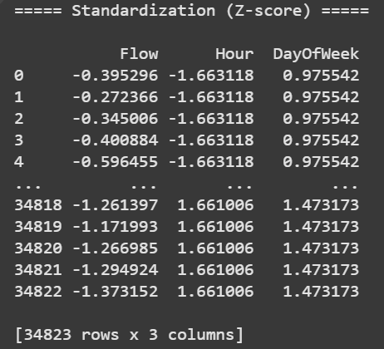  
*Fig 2. shows standardization (Z-score) of the dataset*

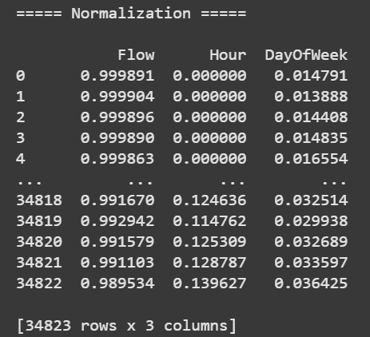

*Fig 3. shows normalization of the dataset*

'Busy' for values interior the driving 25% percentile, 'Average Busy' for the center 50%, and 'Not Busy' for the foot 25%.

Taking after incorporate creation, data scaling is performed to standardize the numerical qualities and make strides appear consolidating. Distinctive scaling methodologies are associated depending on the modeling prerequisites. Min-Max Scaling changes all numerical inputs into a settled expand between and 1, keeping up relative isolating. Standardization, or Z-score normalization, changes the data to have a unfeeling of zero and a standard deviation of one, which is particularly profitable for calculations tricky to variance. At long last, L2 normalization is associated in a couple of models to ensure that incorporate vectors have a relentless enormity, securing relative divisions inside the incorporate space.

1. Model Development

Within the demonstrate improvement stage, both conventional machine learning strategies and profound learning models are explored to recognize the foremost compelling approach for activity classification. Among conventional models, the Choice Tree Classifier develops a tree-like structure where each hub speaks to a choice based on a particular include, and the ideal highlight parts are decided utilizing entropy or Gini pollution measures. Complementing this, the Arbitrary Woodland Classifier utilizes an gathering of choice trees made through bootstrap conglomeration. This strategy progresses generalization and diminishes change, and it assesses highlight significance utilizing the Gini list.

In expansion to these conventional approaches, profound learning models are implemented to handle complex worldly and spatial designs within the information. Fake Neural Systems (ANNs) contain input, covered up, and yield layers, utilizing actuation capacities such as ReLU, Sigmoid, and Softmax. Optimization calculations like Slope Plunge and Adam are utilized during training. Repetitive Neural Systems (RNNs) are utilized to capture consecutive conditions within the information, in spite of the fact that their adequacy is frequently constrained by the vanishing slope issue. To address this, Gated Repetitive Units (GRUs) are presented, which make strides memory maintenance utilizing upgrade and reset entryways, and prepare more effectively than vanilla RNNs. Bidirectional GRUs (Bi-GRUs) amplify this capability by processing input arrangements in both forward and in reverse headings, giving improved setting for transient expectations. Besides, Convolutional Neural Networks (CNNs) are connected to identify spatial designs from sensor or activity framework information, utilizing convolutional channels. Chart Neural Systems (GNNs) are too investigated, modeling street systems as charts to capture spatial conditions between associated convergences and foresee blockage designs based on auxiliary connections.

1. Evaluation Framework

A comprehensive evaluation framework is set up to study illustrate execution utilizing a suite of estimations. Precision is utilized to degree the degree of change figures, while precision and review are utilized to survey the model's capacity to precisely recognize positive classes and minimize unfaithful negatives, independently .The F1-score gives a consonant hardhearted of exactness and overview, advancing a adjusted see of the model's ampleness. The Geometric Hardhearted (G-mean) is especially profitable for overseeing with class-imbalanced datasets, since it reflects the execution over all classes. Besides, Hardhearted Squared Botch (MSE) is utilized to survey regression-based models and degree figure botches.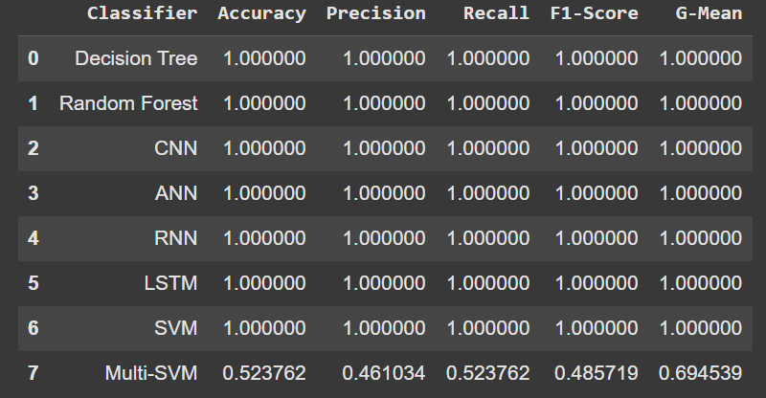

*Fig 4. shows detailed performance metrics of classifiers*

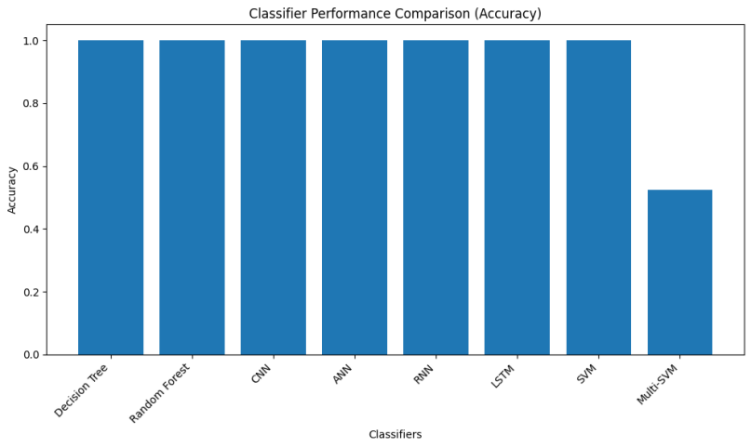

*Fig 5. shows classifier performance comparison*

For comparative examination, the execution of unmistakable models is visualized through graphical representations. Line plots and bar charts format how each show up performs over unmistakable estimations, giving a visual induces to unravel and compare their ampleness.

1. Accuracy:

$Accuracy =\frac{TP + TN}{TP + TN + FP + FN}$

1. Precision:
$$Precision = \frac{TP}{TP + FP}$$

2. Recall :
$$Recall = \frac{TP}{TP + FN}$$

3. F1-score :
$$F1−Score = 2× \frac{Precison × Recall}{Precision + Recall}$$

4. Geometric Mean (G-mean):

Handles imbalanced data.

$$G−Mean = \sqrt{Sensitivity × Specificity}$$

1. Mean Squared Error (MSE) (Regression Analysis):
$$MSE = \frac{1}{n} \sum_{i = 1}^{n}{{\left(y_{i} − y_{pred}\right)}^{2}}$$

2. Traffic Pattern Analysis

Activity classification is advance improved by analyzing designs on an hourly premise. The information is gathered by hour, and the normal activity stream for each hour is computed. Based on percentile edges, activity is classified as 'Busy' in case it falls within the best 25%, 'Not Busy' for the foot 25%, and 'Average Busy' for the remaining 50%.This classification empowers understanding of action behavior all through the day.

Examination reveals that best action hours frequently happen in the midst of early mornings (7 AM to 9 AM) and nights (4 PM to 7 PM), altering with commonplace work commute plans. The foremost sit out of gear activity periods are watched between 12 AM and 6 AM, when street movement is negligible. Early afternoon hours (10 AM to 3 PM) by and large encounter medium activity levels, likely due to lunch breaks or adaptable work hours. Eminently, 3 PM (15:

00) reliably rises as the hour with the most elevated normal activity, affirming discoveries from existing urban clog considers.

1. RESULT ANALYSIS

The outcomes of the machine learning models used for traffic classification are shown in this section. A classification of traffic patterns on an hourly basis was examined, and the models' performance was evaluated using a variety of assessment measures.

Essential Insights from Performance Metrics: Random Forest surpassed Decision Tree in every metric.It led to improved accuracy, precision, recall, and F1 score.The ensemble learning method of Random Forest minimized over-fitting.The low Recall score suggests that some traffic situations were incorrectly classified.The application of feature selection or deep learning techniques might be necessary to gain further improvements.Uneven distribution of class performance is demonstrated by the Geometric Mean (G-mean).For better categorization, a greater number of traffic kinds must be used.The Mean Squared Error remained a notable figure. For the purpose of reducing errors in prediction, the approach could have to be refined.

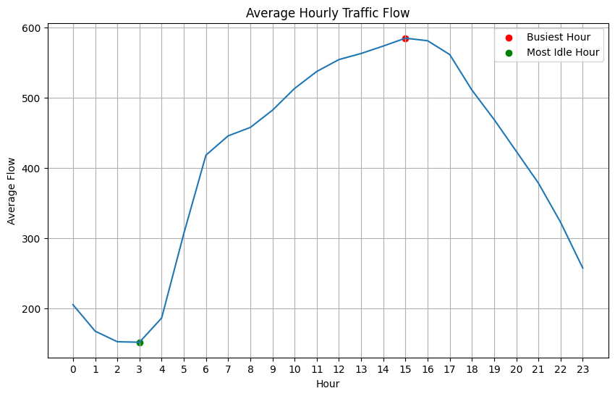

*Fig 6. shows average hourly traffic flow*

Significant Findings from the Study of Traffic Movements: Peak hours are in the early morning (7 AM to 9 AM) and afternoons (4 PM to 7 PM).These were times when traffic was at its peak.Travel and job patterns shape such patterns.'Not Busy' is a classification for the late- night and early in the morning (12 AM to 6 AM) hours.Very little traffic because there wasn't enough activity on roads.During midday (10 AM to 3 PM), medium traffic levels are observed.Traffic varied during this time, maybe as the consequence of work intervals or lunch.15:00 was constantly categorized as a time of rush hour traffic.This is consistent with regular urban traffic trends found in research on congestion.

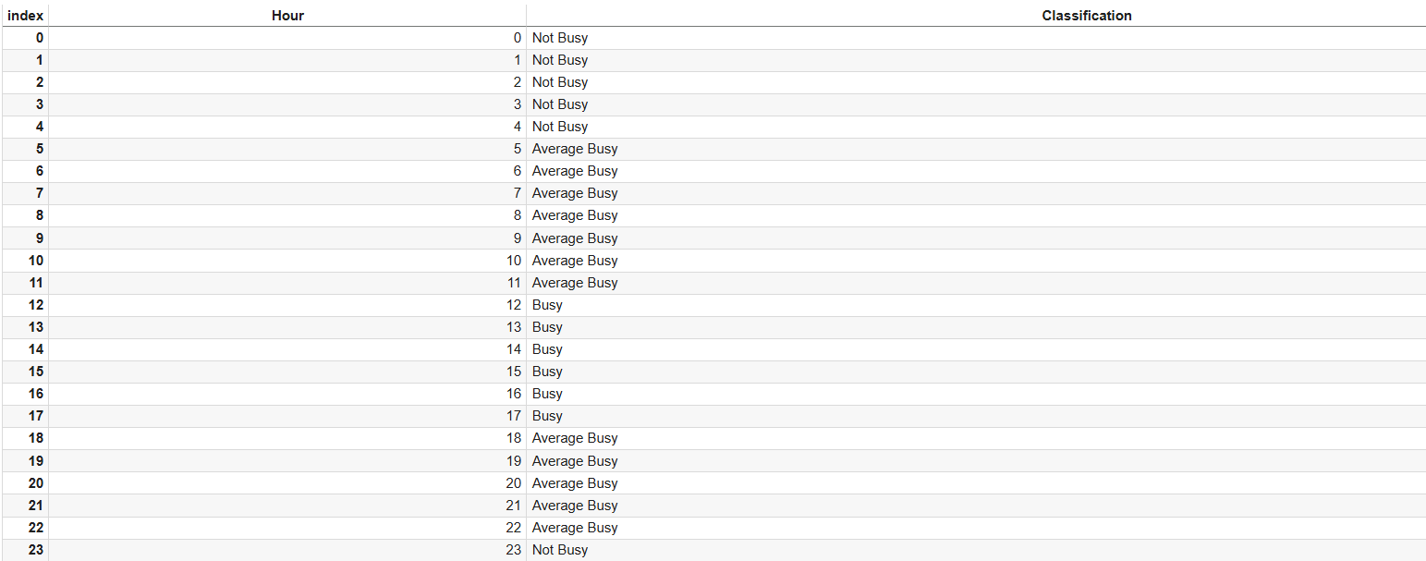

*Fig 7. shows hourly classification of activity levels, categorizing each hour from 0 to 23 as "Not Busy", "Average Busy", or "Busy" based on observed patterns.*

1. CONCLUSION

This report describes the creation of a machine learning pipeline to enhance traffic flow prediction accuracy. The methodology involves data preprocessing, feature extraction, and application of both conventional machine learning models (Decision Tree, Random Forest) and deep learning models (ANN, RNN, GRU, Bi-GRU, CNN, GNN). Traffic data with timestamps and flow measurements were processed to extract time-based features such as hour of the day and weekday/weekend variations. Traffic was classified into three categories: 'Busy', 'Average', and 'Not Busy'. It was observed, using comparative analysis, that the Random Forest model performed better consistently than the Decision Tree in curbing overfitting and providing more accurate outputs. The outputs of the model were graphed to make it easier to interpret. The research highlights how an ML-based approach, particularly with Random Forest, can be used to accurately forecast traffic patterns to help authorities manage traffic congestion. Finally, the system facilitates the development of a smarter, more efficient, and green transport network.

1. REFERENCES
2. Nashaat, H., Mohammed, N. H., Abdel-Mageid, S. M., & Rizk, R. Y. (2024). Machine Learning-based Cellular Traffic Prediction Using Data Reduction Techniques. IEEE Access.
3. Hua, Y., Zhao, Z., Liu, Z., Chen, X., Li, R., & Zhang, H. (2018, August). Traffic prediction based on random connectivity in deep learning with long short-term memory. In 2018 IEEE 88th Vehicular Technology Conference (VTC-Fall) (pp. 1-6). IEEE.
4. Koh, Z., Qin, Y., Guan, Y. L., & Yuen, C. (2023, March). A Slow Shifting Concerned Machine Learning Method for Short-term Traffic Flow Forecasting. In 2023 IEEE International Conference on Smart Mobility (SM) (pp. 9-14). IEEE.
5. Modi, S., Bhattacharya, J., & Basak, P. (2022). Multistep traffic speed prediction: A deep learning based approach using latent space mapping considering spatio-temporal dependencies. Expert Systems with Applications, 189, 116140.
6. Wang, W., & Li, X. (2018). Travel speed prediction with a hierarchical convolutional neural network and long short-term memory model framework. arXiv preprint arXiv:1809.01887.
7. Wang, H., Wei, X., Yao, J., & Zhang, Y. (2021, December). Traffic flow prediction using machine learning methods. In 2021 3rd International Conference on Machine Learning, Big Data and Business Intelligence (MLBDBI) (pp. 30-35). IEEE
8. Chaoura, C., Lazar, H., & Jarir, Z. (2022, October). Predictive system of traffic congestion based on machine learning. In 2022 9th International Conference on Wireless Networks and Mobile Communications (WINCOM) (pp. 1-6). IEEE.
9. Sharma, A., & Ranjan, P. (2023, August). Traffic Prediction Model Using Machine Learning in Intelligent Transportation Systems. In 2023 International Conference on Circuit Power and Computing Technologies (ICCPCT) (pp. 1165-1173). IEEE.
10. Kafy, M. A., Faisal, S. I., Rahman, M. L., Moni, R., Shanmuganathan, H., & Raza, D. M. (2024, February). Traffic Congestion Prediction using Machine Learning. In 2024 11th International Conference on Computing for Sustainable Global Development (INDIACom) (pp. 1290-1295). IEEE.
11. Moses, A., & Parvathi, R. (2020, February). Vehicular traffic analysis and prediction using machine learning algorithms. In 2020 International Conference on Emerging Trends in Information Technology and Engineering (ic-ETITE) (pp. 1-4). IEEE.
12. Meena, G., Sharma, D., & Mahrishi, M. (2020, February). Traffic prediction for intelligent transportation system using machine learning. In 2020 3rd International Conference on Emerging Technologies in Computer Engineering: Machine Learning and Internet of Things (ICETCE) (pp. 145-148). IEEE.
13. Shao, Y., Zheng, Y., & Sun, Z. (2021, May). Machine learning enabled traffic prediction for speed optimization of connected and autonomous electric vehicles. In 2021 American Control Conference (ACC) (pp. 172-177). IEEE.
14. Deb, B., Khan, S. R., Hasan, K. T., Khan, A. H., & Alam, M. A. (2019, March). Travel time prediction using machine learning and weather impact on traffic conditions. In 2019 IEEE 5th International Conference for Convergence in Technology (I2CT) (pp. 1-8). IEEE.
15. Xia, H., Wei, X., Gao, Y., & Lv, H. (2019, May). Traffic prediction based on ensemble machine learning strategies with bagging and lightgbm. In 2019 IEEE International Conference on Communications Workshops (ICC Workshops) (pp. 1-6). IEEE.
16. Modi, S., Bhattacharya, J., & Basak, P. (2022). Multistep traffic speed prediction: A deep learning based approach using latent space mapping considering spatio-temporal dependencies. Expert Systems with Applications, 189, 116140.
17. Razali, N. A. M., Shamsaimon, N., Ishak, K. K., Ramli, S., Amran, M. F. M., & Sukardi, S. (2021). Gap, techniques and evaluation: traffic flow prediction using machine learning and deep learning. Journal of Big Data, 8, 1-25.
18. Yu, R., Li, Y., Shahabi, C., Demiryurek, U., & Liu, Y. (2017, June). Deep learning: A generic approach for extreme condition traffic forecasting. In Proceedings of the 2017 SIAM international Conference on Data Mining (pp. 777-785). Society for Industrial and Applied Mathematics.
19. Braz, F. J., Ferreira, J., Gonçalves, F., Weege, K., Almeida, J., Baldo, F., & Gonçalves, P. (2022). Road traffic forecast based on meteorological information through deep learning methods. Sensors, 22(12), 4485.
20. Wang, J., Chen, R., & He, Z. (2019). Traffic speed prediction for urban transportation network: A path based deep learning approach. Transportation Research Part C: Emerging Technologies, 100, 372-385.
21. Lu, Z., Lv, W., Xie, Z., Du, B., & Huang, R. (2019, August). Leveraging graph neural network with lstm for traffic speed prediction. In 2019 IEEE SmartWorld, Ubiquitous Intelligence & Computing, Advanced & Trusted Computing, Scalable Computing & Communications, Cloud & Big Data Computing, Internet of People and Smart City Innovation (SmartWorld/SCALCOM/UIC/ATC/CBDCom/IOP/SCI) (pp. 74-81). IEEE.
22. Li, M., & Zhu, Z. (2021, May). Spatial-temporal fusion graph neural networks for traffic flow forecasting. In Proceedings of the AAAI conference on artificial intelligence (Vol. 35, No. 5, pp. 4189-4196).
23. Zheng, C., Fan, X., Wang, C., & Qi, J. (2020, April). Gman: A graph multi-attention network for traffic prediction. In Proceedings of the AAAI conference on artificial intelligence (Vol. 34, No. 01, pp. 1234-1241).
24. Li, Y., Yu, R., Shahabi, C., & Liu, Y. (2017). Diffusion convolutional recurrent neural network: Data-driven traffic forecasting. arXiv preprint arXiv:1707.01926.
25. Zhang, Y., Zhao, T., Gao, S., & Raubal, M. (2023). Incorporating multimodal context information into traffic speed forecasting through graph deep learning. International Journal of Geographical Information Science, 37(9), 1909-1935.
26. Shin, T. (2023). Understanding Feature Importance in Machine Learning. Accessed on, 26, 2024.
27. Shao, J., Zheng, C., Chen, Y., Huang, Y., & Zhang, R. (2024). MoveLight: Enhancing Traffic Signal Control through Movement-Centric Deep Reinforcement Learning. arXiv preprint arXiv:2407.17303.
28. Sundaravadivel, P., Mohanty, S. P., Kougianos, E., & Albalawi, U. (2016, April). An energy efficient sensor for thyroid monitoring through the iot. In 2016 17th International Conference on Thermal, Mechanical and Multi-Physics Simulation and Experiments in Microelectronics and Microsystems (EuroSimE) (pp. 1-4). IEEE.
29. Aslani, M., Mesgari, M. S., & Wiering, M. (2017). Adaptive traffic signal control with actor-critic methods in a real-world traffic network with different traffic disruption events. Transportation Research Part C: Emerging Technologies, 85, 732-752
30. Wei, H., Zheng, G., Yao, H., & Li, Z. (2018, July). Intellilight: A reinforcement learning approach for intelligent traffic light control. In Proceedings of the 24th ACM SIGKDD international conference on knowledge discovery & data mining (pp. 2496-2505).
31. Liang, X., Du, X., Wang, G., & Han, Z. (2019). A deep reinforcement learning network for traffic light cycle control. IEEE Transactions on Vehicular Technology, 68(2), 1243-1253.